### **Test Report ABC-NN: <insert name of the test here>**

*This test report must be read in conjunction with Test Plan ABC-NN: <insert name of the test here>*

#### Signoff code: abc123xyz

#### Clause 1

##### Objective:

<state objective here>

##### Equipment and Materials:

1. <equipment 1>
2. <material 1>
3. <material 2>

##### Test Setup:

<insert image of the setup with labels> e.g.

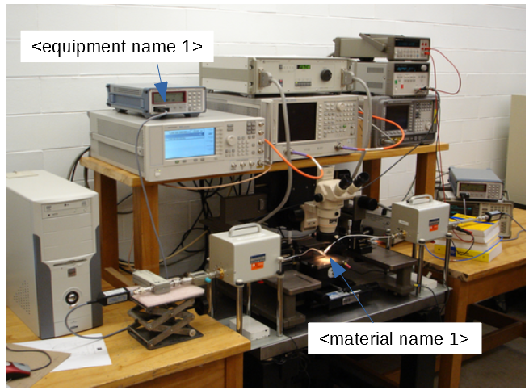

<insert description of each label>

###### Setup instructions

<insert placement instruction> e.g. connect the wire of <equipment xx> to the <equipment yy>

###### Perform these checks before performing the test

<insert checks here>

##### Procedure

1. <load sample>
2. <perform test>
3. <measure data>

##### Results

|  |  |
| --- | --- |
| **Input** | **Output** |
| <input param 1> | <output 1> |
| <input param 2> | <output 2> |
|  |  |

###### Conclusion

<summarize result into 1 sentence>

<pass/fail the related requirement?>

<further tests to be done?>